

**ELLENA**

**ONLINE WOMEN FASHION SHOP**

**Software Design Document**

– Ho Chi Minh, May 2022 –

**Table of Contents**

I. Overview **5**

1. Code Packages/Namespaces 5

2. Database Schema 6

II. Code Designs **7**

1. Account Management 7

a. Class Diagram 7

b. Class Specifications 8

UserDAO 8

UserDTO 9

UserError 9

DBUtils 9

AddAccountController 9

ShowAccountController 9

RegisterController 9

ActivateAccountController 10

DeactivateAccountController 10

SearchAccountController 10

UpdateAccountController 10

c. Sequence Diagram(s) 11

d. Database queries 13

2. Product Management 15

a. Class Diagram 15

b. Class Specifications 15

ProductDAO 15

ProductDTO 16

DBUtils 16

AddProductController 16

ManagerUpdateProductController 17

ProductRouteController 17

ManagerShowProductController 17

ManagerShowProductDetailController 17

ViewHomeController 17

ActivateProductController 18

DeactivateProductController 18

FilterSearchedProductController 18

FilterCategoryProductController 18

c. Sequence Diagram(s) 19

Figure 2.1: Create a product 19

Figure 2.2: Search for products - Manager 20

d. Database queries 21

3. Order Management 23

a. Class Diagram 23

b. Class Specifications 23

OrderDAO 23

OrderDTO 24

OrderDetailDTO 24

OrderStatusDTO 24

OrderError 24

DBUtils 25

SearchOrderController 25

UpdateOrderController 25

CancelOrderController 25

ViewOrderHistoryController 25

CheckoutController 25

MomoRequestController 26

CustomerViewOrderDetailController 26

ShowOrderController 26

ajaxServlet 26

JavaMailUtils 26

c. Sequence Diagram(s) 27

d. Database queries 28

III. Database Tables **30**

1. tblRoles 30

2. tblUsers 30

3. tblOrderStatus 30

4. tblOrder 30

5. tblCategory 31

6. tblProduct 31

7. tblProductColors 31

8. tblColorImage 31

9. tblColorSizes 31

10. tblRating 32

11. tblOrderDetail 32

12. tblOrderStatusUpdate 32

13. tblCart 32

14. tblCartItems 33

15. tblReturns 33

# I. Overview

## 1. Code Packages/Namespaces

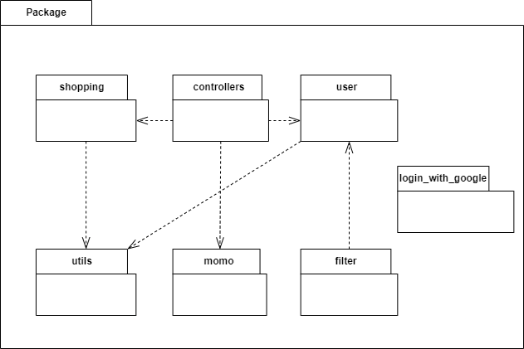

***Package descriptions & package class naming conventions***

| **No** | **Package** | **Description** |
| --- | --- | --- |
| 01 | store | This package contains all the other packages in this Web app. |
| 02 | controllers | This package contains classes for all the controllers in the app  Class naming convention: ActionController |
| 03 | shopping | This package contains classes for product items and carts.  Class naming convention: ItemDAO, ItemDTO,... |
| 04 | user | This package contains classes for processing users’ data.  Class naming convention: UserDAO, UserDTO,... |
| 05 | login_with_google | This package contains classes for processing Google Sign-in accounts’ information. |
| 06 | momo | This package contains classes for processing Momo online payment. |
| 07 | utils | This package contains classes for common functions. |

## 2. Database Schema

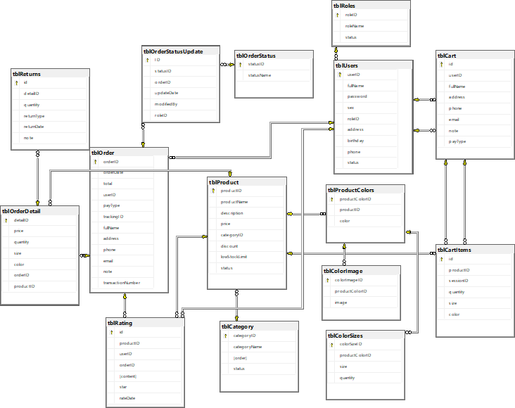

***Table descriptions & package class naming conventions are as below***

| **No** | **Table** | **Description** |
| --- | --- | --- |
| 1 | tblUsers | Used to store all accounts infomation.  - Primary key: userID  - Foreign key: roleID |
| 2 | tblRoles | Used to limit account permission.  - Primary key: roleID |
| 3 | tblRating | Used to store products rating from customers.  - Primary keys: productID, userID  - Foreign keys: productID, userID |
| 4 | tblOrder | Used to store all orders infomation.  - Primary key: orderID  - Foreign key: statusID |
| 5 | tblOrderStatus | Used to differentiate each order status.  - Primary key: statusID |
| 6 | tblOrderDetail | Used to store the detail in each customer’s order (products, quantity, total price)  - Primary key: detailID  - Foreign keys: orderID, productID |
| 7 | tblProduct | Used to store all the product details  - Primary key: productID  - Foreign key: categoryID |
| 8 | tblCategory | Used to separate different kinds of product.  - Primary key: categoryID |
| 9 | tblProductDetail | Used to store all the product’s variants detail (size,color)  - Primary keys: productID, size, color  - Foreign key: productID |

# II. Code Designs

## 1. Account Management

### a. Class Diagram

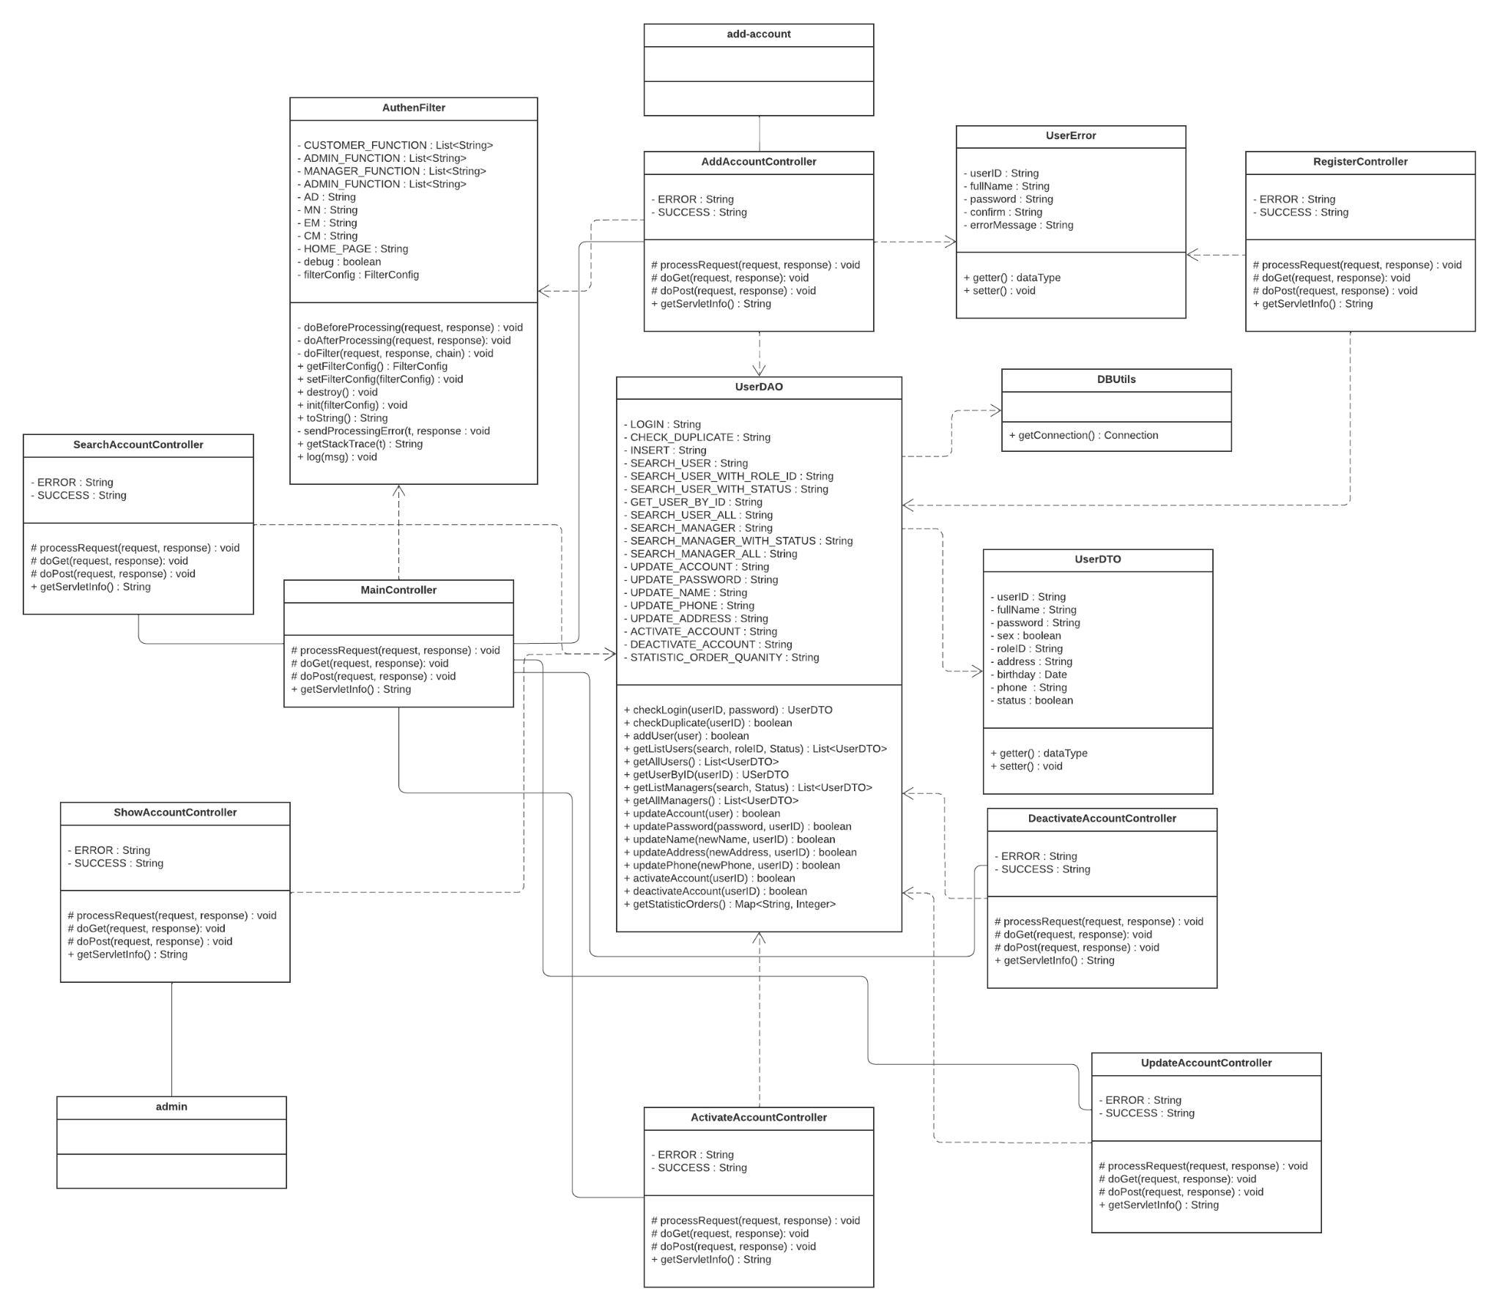

### b. Class Specifications

#### UserDAO

| **No** | **Method** | **Description** |
| --- | --- | --- |
| 01 | checkLogin(userID, password) | Check whether an user has an existing account or not |
| 02 | checkDuplicate(userID) | Check whether an userID is duplicated |
| 03 | addUser(user) | Insert an user into the database |
| 04 | getListUsers(search, roleID, Status) | Return a list of users with some criteria |
| 05 | getAllUsers() | Return the list of all users |
| 06 | getUserByID(userID) | Return a user that has the requested userID. |
| 07 | getListManagers(search, Status) | Return a list of searched managers |
| 08 | getAllManagers() | Return the list of all managers |
| 09 | updateAccount(user) | Update an account |
| 10 | updatePassword(password, userID) | Update password of an account |
| 11 | updateName(newName, userID) | Update name of an account |
| 12 | updateAddress(newAddress, userID) | Update address of an account |
| 13 | updatePhone(newPhone, userID) | Update phone of an account |
| 14 | updateSex(newSex, userID) | Update sex of an account |
| 16 | updateBirthday(newBirthday, userID) | Update birthday of an account |
| 17 | deactivateAccount(userID) | Change an account’s status to inactive |
| 18 | activateAccount(userID) | Change an account’s status to active |

#### UserDTO

| **No** | **Method** | **Description** |
| --- | --- | --- |
| 01 | getter() | Get an attribute’s value |
| 02 | setter() | Set an attribute’s value |

#### UserError

| **No** | **Method** | **Description** |
| --- | --- | --- |
| 01 | getter() | Get an attribute’s value |
| 02 | setter() | Set an attribute’s value |

#### 

#### DBUtils

| **No** | **Method** | **Description** |
| --- | --- | --- |
| 01 | getConnection() | Return a Connection to connect to the database |

#### 

#### AddAccountController

| **No** | **Method** | **Description** |
| --- | --- | --- |
| 01 | processRequest() | Process a request from the user. |
| 02 | doGet() | Process a GET request from the user. |
| 03 | doPost() | Process a POST request from the user. |
| 04 | getServletInfo() | Get the servlet’s info |

#### ShowAccountController

| **No** | **Method** | **Description** |
| --- | --- | --- |
| 01 | processRequest() | Process a request from the user. |
| 02 | doGet() | Process a GET request from the user. |
| 03 | doPost() | Process a POST request from the user. |
| 04 | getServletInfo() | Get the servlet’s info |

#### RegisterController

| **No** | **Method** | **Description** |
| --- | --- | --- |
| 01 | processRequest() | Process a request from the user. |
| 02 | doGet() | Process a GET request from the user. |
| 03 | doPost() | Process a POST request from the user. |
| 04 | getServletInfo() | Get the servlet’s info |

#### 

#### ActivateAccountController

| **No** | **Method** | **Description** |
| --- | --- | --- |
| 01 | processRequest() | Process a request from the user. |
| 02 | doGet() | Process a GET request from the user. |
| 03 | doPost() | Process a POST request from the user. |
| 04 | getServletInfo() | Get the servlet’s info |

#### 

#### DeactivateAccountController

| **No** | **Method** | **Description** |
| --- | --- | --- |
| 01 | processRequest() | Process a request from the user. |
| 02 | doGet() | Process a GET request from the user. |
| 03 | doPost() | Process a POST request from the user. |
| 04 | getServletInfo() | Get the servlet’s info |

#### SearchAccountController

| **No** | **Method** | **Description** |
| --- | --- | --- |
| 01 | processRequest() | Process a request from the user. |
| 02 | doGet() | Process a GET request from the user. |
| 03 | doPost() | Process a POST request from the user. |
| 04 | getServletInfo() | Get the servlet’s info |

#### UpdateAccountController

| **No** | **Method** | **Description** |
| --- | --- | --- |
| 01 | processRequest() | Process a request from the user. |
| 02 | doGet() | Process a GET request from the user. |
| 03 | doPost() | Process a POST request from the user. |
| 04 | getServletInfo() | Get the servlet’s info |

### c. Sequence Diagram(s)

#### Figure 1.1: Sign up

#### Figure 1.2: Login

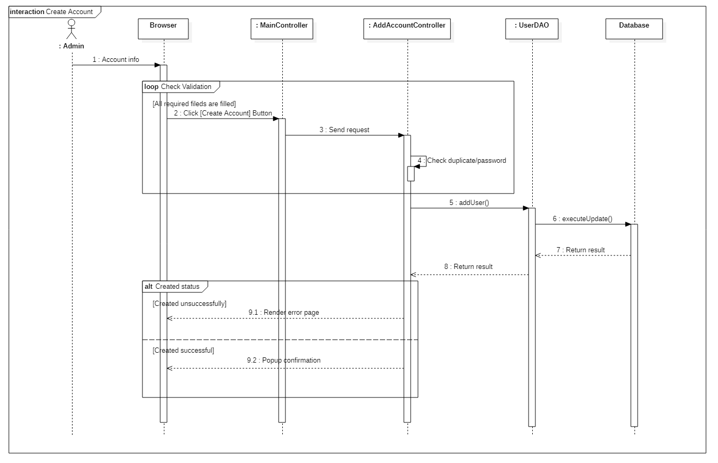

#### Figure 1.3: Create an account - Administrator

### d. Database queries

* String INSERT = INSERT tblUsers(userID, fullName, password, sex, roleID, address, birthday, phone, status) VALUES(?, ?, ?, ?, ?, ?, ?, ?, ?)
* String CHECK_DUPLICATE = "SELECT fullName FROM tblUsers WHERE userID=?"
* String LOGIN = "SELECT fullName, sex, roleID, address, birthday, phone, status FROM tblUsers WHERE userID=? AND password=?"
* String SEARCH_USER = "SELECT userID, fullName, sex, roleID, address, birthday, phone, status FROM tblUsers WHERE userID LIKE ?"
* String SEARCH_USER_WITH_ROLE_ID = "SELECT userID, fullName, sex, roleID, address, birthday, phone, status FROM tblUsers WHERE userID LIKE ? AND roleID LIKE ?"
* String SEARCH_USER_WITH_STATUS = "SELECT userID, fullName, sex, roleID, address, birthday, phone, status FROM tblUsers WHERE userID LIKE ? AND roleID LIKE ? AND status=?"
* String GET_USER_BY_ID = "SELECT userID, fullName, password, sex, roleID, address, birthday, phone, status FROM tblUsers WHERE userID=?"
* String SEARCH_USER_ALL = "SELECT userID, fullName, sex, roleID, address, birthday, phone, status FROM tblUsers"
* String SEARCH_MANAGER = "SELECT userID, fullName, sex, roleID, address, birthday, phone, status FROM tblUsers WHERE userID LIKE ? AND roleID LIKE 'MN'"
* String SEARCH_MANAGER_WITH_STATUS = "SELECT userID, fullName, sex, roleID, address, birthday, phone, status FROM tblUsers WHERE userID LIKE ? AND roleID LIKE 'MN' AND status=?"
* String SEARCH_MANAGER_ALL = "SELECT userID, fullName, sex, roleID, address, birthday, phone, status FROM tblUsers WHERE roleID LIKE 'MN'"
* String UPDATE_ACCOUNT = "UPDATE tblUsers SET fullName=?, sex=?, roleID=?, address=?, birthday=?, phone=? WHERE userID=?"
* String UPDATE_PASSWORD = "UPDATE tblUsers SET password=? WHERE userID=?"
* String UPDATE_NAME = "UPDATE tblUsers SET fullName=? WHERE userID=?"
* String UPDATE_SEX = "UPDATE tblUsers SET sex=? WHERE userID=?"
* String UPDATE_BIRTHDAY = "UPDATE tblUsers SET birthday=? WHERE userID=?"
* String UPDATE_ADDRESS = "UPDATE tblUsers SET address=? WHERE userID=?"
* String UPDATE_PHONE = "UPDATE tblUsers SET phone=? WHERE userID=?"
* String ACTIVATE_ACCOUNT = "UPDATE tblUsers SET status=1 WHERE userID=?"
* String DEACTIVATE_ACCOUNT = "UPDATE tblUsers SET status=0 WHERE userID=?"

## 2. Product Management

### a. Class Diagram

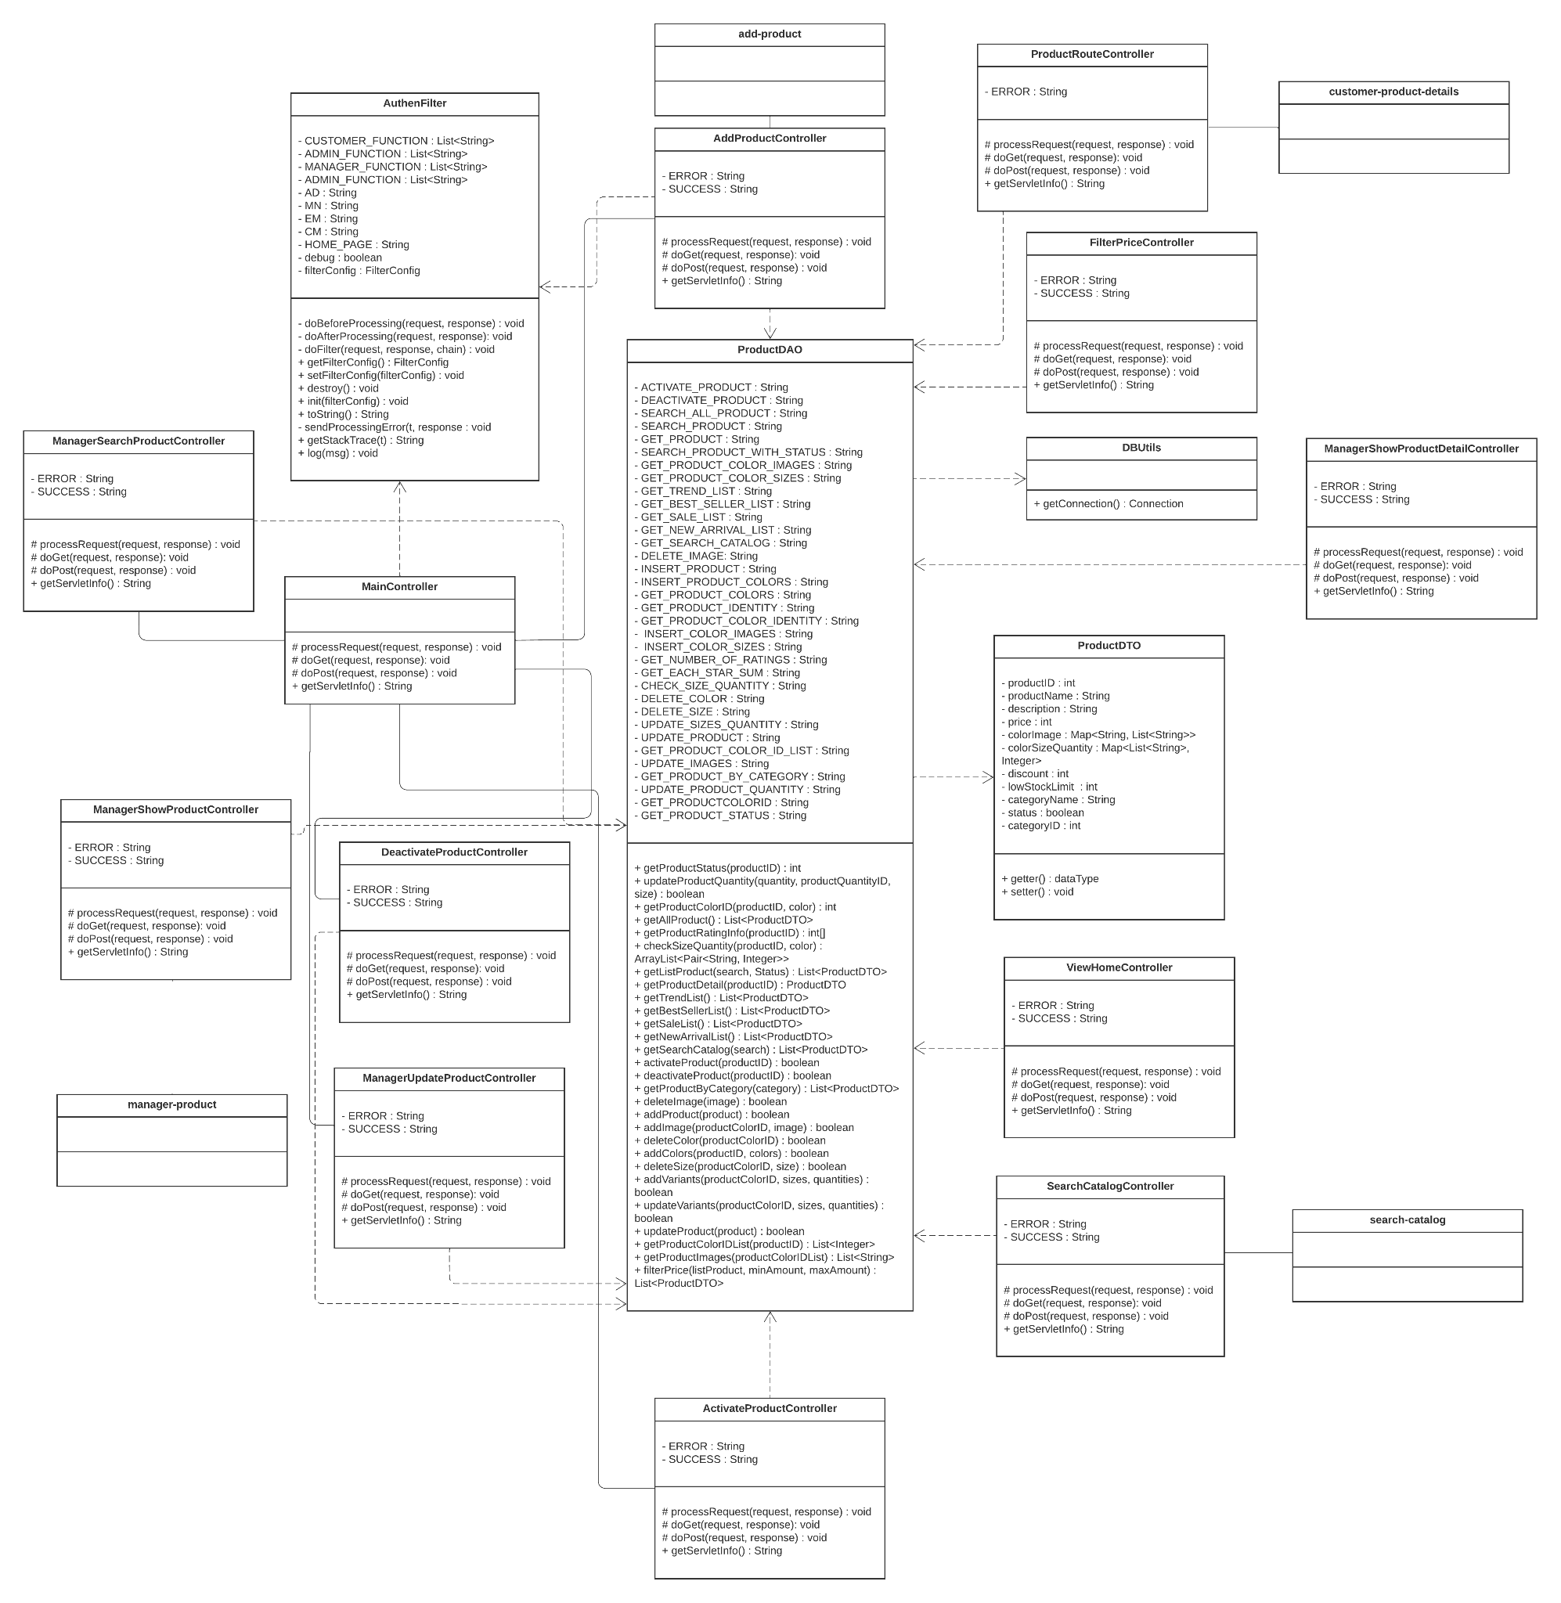

### b. Class Specifications

#### ProductDAO

| **No** | **Method** | **Description** |
| --- | --- | --- |
| 01 | addProduct(product) | Add a product to the database |
| 02 | getProductStatus(productID) | Return a product’s status |
| 03 | updateProductQuantity(quantity, productQuantityID, size) | Update a product quantity by its size |
| 04 | getProductColorID(productID, color) | Return ID of a product’s color |
| 05 | getAllProduct() | Return the list of all products |
| 06 | getProductRatingInfo(productID) | Return details of a product’s rating |
| 07 | checkSizeQuantity(productID, color) | Return an array list of all sizes and colors of a product |
| 08 | getListProduct(search, Status) | Return the list of searched products |
| 09 | getProductDetail(productID) | Return the all detailed information of a product |
| 10 | getTrendList() | Get the list of trendy clothes |
| 11 | getBestSellerList() | Get the list of best seller clothes |
| 12 | getSaleList() | Get the list of clothes that are on sales |
| 13 | getNewArrivalList() | Get the list of new clothes |
| 14 | getSearchCatalog(search) | Return the list of searched products for customers |
| 16 | getProductByCategory(category) | Retrieve all products under a category |
| 17 | deactivateProduct(productID) | Change a product’s status to inactive |
| 18 | activateProduct(productID) | Change a product’s status to active |
| 19 | deleteImage(image) | Delete an image of a product |
| 20 | addImage(productColorID, image) | Add an image of a product’s color |
| 21 | filterSearchedProducts(search, minAmount, maxAmount) | Return the searched list of products that matched the criteria |
| 22 | getProductImages(productColorIDList) | Get all product images for the inputted colors |
| 23 | getProductColorIDList(productID) | Get all IDs for a product’s color |
| 24 | deleteColor(productColorID) | Delete a color from a product |
| 25 | addVariants(productColorID, sizes, quantities) | Add a variant for a product |
| 26 | updateVariants(productColorID, sizes, quantities) | Update a variant for a product |
| 27 | updateProduct(product) | Update a product |
| 28 | addColors(productID, colors) | Add a list of colors to a product |
| 29 | deleteSize(productColorID, size) | Delete a size of a product |
| 30 | filterCategoryProducts(category, minAmount, maxAmount) | Return the list of products that matched the criteria in a specific category |

#### ProductDTO

| **No** | **Method** | **Description** |
| --- | --- | --- |
| 01 | getter() | Get an attribute’s value |
| 02 | setter() | Set an attribute’s value |

#### 

#### DBUtils

| **No** | **Method** | **Description** |
| --- | --- | --- |
| 01 | getConnection() | Return a Connection to connect to the database |

#### 

#### AddProductController

| **No** | **Method** | **Description** |
| --- | --- | --- |
| 01 | processRequest() | Process a request from the user. |
| 02 | doGet() | Process a GET request from the user. |
| 03 | doPost() | Process a POST request from the user. |
| 04 | getServletInfo() | Get the servlet’s info |

#### ManagerUpdateProductController

| **No** | **Method** | **Description** |
| --- | --- | --- |
| 01 | processRequest() | Process a request from the user. |
| 02 | doGet() | Process a GET request from the user. |
| 03 | doPost() | Process a POST request from the user. |
| 04 | getServletInfo() | Get the servlet’s info |

#### ProductRouteController

| **No** | **Method** | **Description** |
| --- | --- | --- |
| 01 | processRequest() | Process a request from the user. |
| 02 | doGet() | Process a GET request from the user. |
| 03 | doPost() | Process a POST request from the user. |
| 04 | getServletInfo() | Get the servlet’s info |

#### ManagerShowProductController

| **No** | **Method** | **Description** |
| --- | --- | --- |
| 01 | processRequest() | Process a request from the user. |
| 02 | doGet() | Process a GET request from the user. |
| 03 | doPost() | Process a POST request from the user. |
| 04 | getServletInfo() | Get the servlet’s info |

#### ManagerShowProductDetailController

| **No** | **Method** | **Description** |
| --- | --- | --- |
| 01 | processRequest() | Process a request from the user. |
| 02 | doGet() | Process a GET request from the user. |
| 03 | doPost() | Process a POST request from the user. |
| 04 | getServletInfo() | Get the servlet’s info |

#### 

#### ViewHomeController

| **No** | **Method** | **Description** |
| --- | --- | --- |
| 01 | processRequest() | Process a request from the user. |
| 02 | doGet() | Process a GET request from the user. |
| 03 | doPost() | Process a POST request from the user. |
| 04 | getServletInfo() | Get the servlet’s info |

#### ActivateProductController

| **No** | **Method** | **Description** |
| --- | --- | --- |
| 01 | processRequest() | Process a request from the user. |
| 02 | doGet() | Process a GET request from the user. |
| 03 | doPost() | Process a POST request from the user. |
| 04 | getServletInfo() | Get the servlet’s info |

#### DeactivateProductController

| **No** | **Method** | **Description** |
| --- | --- | --- |
| 01 | processRequest() | Process a request from the user. |
| 02 | doGet() | Process a GET request from the user. |
| 03 | doPost() | Process a POST request from the user. |
| 04 | getServletInfo() | Get the servlet’s info |

#### FilterSearchedProductController

| **No** | **Method** | **Description** |
| --- | --- | --- |
| 01 | processRequest() | Process a request from the user. |
| 02 | doGet() | Process a GET request from the user. |
| 03 | doPost() | Process a POST request from the user. |
| 04 | getServletInfo() | Get the servlet’s info |

#### FilterCategoryProductController

| **No** | **Method** | **Description** |
| --- | --- | --- |
| 01 | processRequest() | Process a request from the user. |
| 02 | doGet() | Process a GET request from the user. |
| 03 | doPost() | Process a POST request from the user. |
| 04 | getServletInfo() | Get the servlet’s info |

### c. Sequence Diagram(s)

#### Figure 2.1: Create a product

#### Figure 2.2: Search for products - Manager

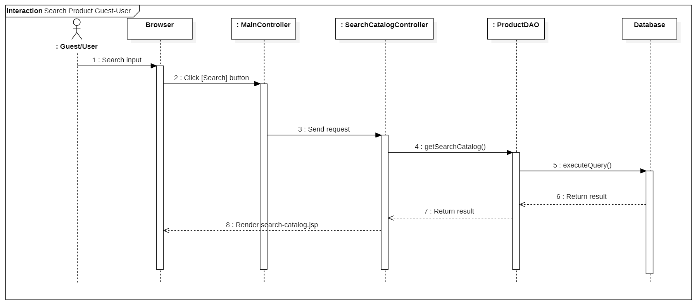

#### Figure 2.3: Search for products - Customer/Guest

#### Figure 2.4: Add a product - Manager

#### Figure 2.5: Update a product - Manager

### d. Database queries

* String INSERT_PRODUCT = "INSERT INTO tblProduct(productName, description, price, categoryID, discount, lowStockLimit, status) VALUES(?, ?, ?, ?, ?, ?, ?)"
* String GET_PRODUCT_IDENTITY = "SELECT IDENT_CURRENT('tblProduct')"
* INSERT_PRODUCT_COLORS = "INSERT INTO tblProductColors(productID, color) VALUES(?, ?)"
* String INSERT_COLOR_IMAGES = "INSERT INTO tblColorImage(productColorID, image) VALUES(?, ?)"
* String INSERT_COLOR_SIZES = "INSERT INTO tblColorSizes(productColorID, size, quantity) VALUES(?, ?, ?)"
* String SEARCH_PRODUCT = "SELECT productID, productName, price, categoryName, discount, lowStockLimit, p.status FROM tblProduct p JOIN tblCategory c ON p.categoryID=c.categoryID AND dbo.fuChuyenCoDauThanhKhongDau(productName) LIKE ?"
* String SEARCH_PRODUCT_WITH_STATUS = "SELECT productID, productName, price, categoryName, discount, lowStockLimit, p.status FROM tblProduct p JOIN tblCategory c ON p.categoryID=c.categoryID AND dbo.fuChuyenCoDauThanhKhongDau(productName) LIKE ? AND p.status=?"
* String GET_SEARCH_CATALOG = "SELECT p.productID, p.productName, p.price, p.discount, i.image, color, size FROM tblProduct p JOIN tblProductColors pc ON p.productID = pc.productID JOIN tblColorImage i ON pc.productColorID = i.productColorID JOIN tblColorSizes cs ON cs.productColorID = pc.productColorID WHERE dbo.fuChuyenCoDauThanhKhongDau(p.productName) LIKE ?"
* INSERT_PRODUCT = “INSERT INTO tblProduct(productName, description, price, categoryID, discount, lowStockLimit, status) VALUES(?, ?, ?, ?, ?, ?, ?)”
* GET_PRODUCT_IDENTITY = “SELECT IDENT_CURRENT('tblProduct')”
* INSERT_PRODUCT_COLORS = “INSERT INTO tblProductColors(productID, color) VALUES(?, ?)”
* GET_PRODUCT_COLOR_IDENTITY = “SELECT IDENT_CURRENT('tblProductColors')”
* INSERT_COLOR_IMAGES = “INSERT INTO tblColorImage(productColorID, image) VALUES(?, ?)”
* INSERT_COLOR_SIZES = ”INSERT INTO tblColorSizes(productColorID, size, quantity) VALUES(?, ?, ?)”
* SEARCH_ALL_PRODUCT = “SELECT productID, productName, price, categoryName, discount, lowStockLimit, p.status FROM tblProduct p JOIN tblCategory c ON p.categoryID=c.categoryID”
* UPDATE_PRODUCT = “UPDATE tblProduct SET productName=?, description=?, price=?, categoryID=?, discount=?, lowStockLimit=?, status=? WHERE productID=?”
* GET_PRODUCT_COLOR_ID_LIST = “SELECT productColorID FROM tblProductColors WHERE productID = ?”
* getProductImage() = “SELECT image FROM tblColorImage WHERE productColorID in (...?..., …image…)”
* UPDATE_IMAGES = “UPDATE tblColorImage SET image=? WHERE image=?”
* GET_PRODUCT = “SELECT productID, productName, price, description, categoryName, discount, lowStockLimit, p.status FROM tblProduct p JOIN tblCategory c ON p.categoryID=c.categoryID AND productID=?”
* GET_PRODUCT_COLORS = “SELECT color FROM tblProductColors WHERE productID=?”
* GET_PRODUCT_COLOR_IMAGES = “SELECT color, image FROM tblProduct p JOIN tblProductColors pc ON p.productID = pc.productID AND p.productID = ? JOIN tblColorImage ci ON ci.productColorID = pc.productColorID”
* GET_PRODUCT_COLOR_SIZES = “SELECT color, size, quantity FROM tblProduct p JOIN tblProductColors pc ON p.productID = pc.productID AND p.productID = ? JOIN tblColorSizes cs ON cs.productColorID = pc.productColorID”

## 3. Order Management

### a. Class Diagram

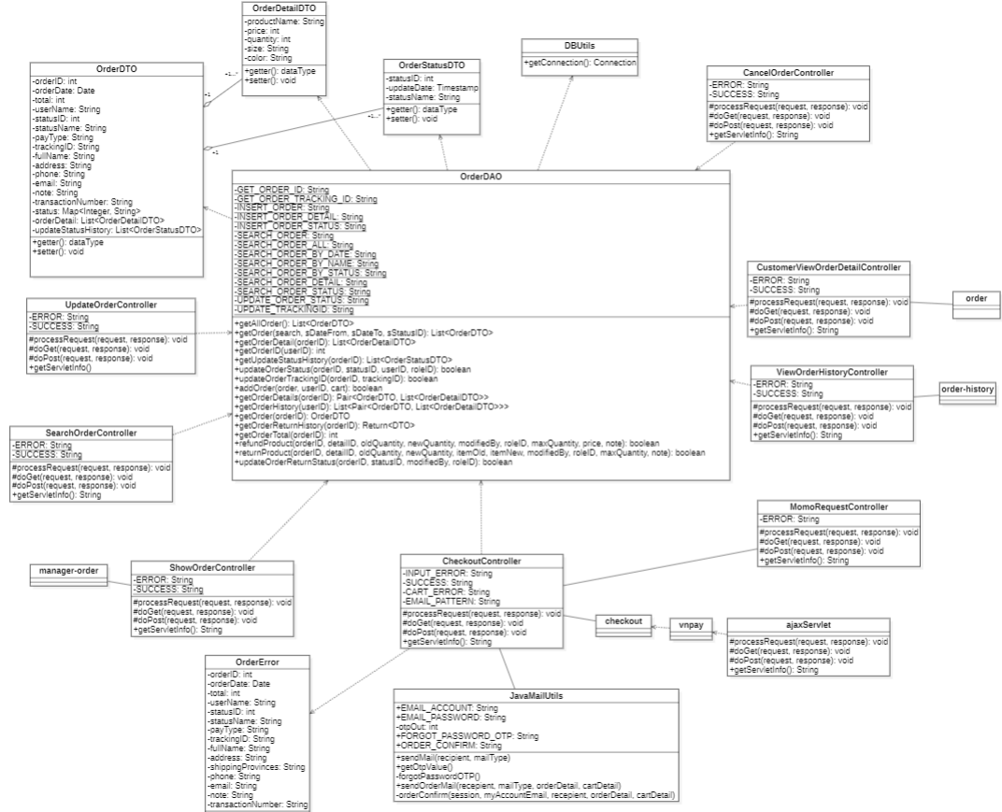

### b. Class Specifications

#### OrderDAO

| **No** | **Method** | **Description** |
| --- | --- | --- |
| 01 | getOrder(search, sDateFrom, sDateTo, sStatusID) | Return a list of orders that matched inputted criteria |
| 02 | getOrderDetail(orderID) | Get order detail for a specific order |
| 03 | addOrder(order, userID, cart) | Insert an order with items into the database |
| 04 | getOrderID(userID) | Get the newest order from the customer |
| 05 | getAllOrder() | Get all orders |
| 06 | getUpdateStatusHistory(orderID) | Return a list of statuses of an order |
| 07 | updateOrderStatus(orderID, statusID, userID, roleID) | Update status of an order |
| 08 | updateOrderTrackingID(orderID, trackingID) | Update a tracking ID of an order |
| 09 | getOrderDetails(orderID) | Return a pair in which the order is the key and order details are the values. |
| 10 | getOrderHistory(userID) | Return order history of a customer |
| 11 | getOrder(orderID) | Get an order by its order ID |
| 12 | getOrderReturnHistory(orderID) | Retrieve the product return/exchanged history for an order of a customer |
| 13 | getOrderTotal(orderID) | Return the total price of an order |
| 14 | refundProduct(orderID, detailID, oldQuantity,newQuantity, modifiedBy, roleID, maxQuantity, price, note) | Add a product to the return history and update the quantity in order detail |
| 15 | returnProduct(orderID, detailID, oldQuantity, newQuantity, itemOld, itemNew, modifiedBy,roleID, maxQuantity, note) | Add a product to the exchanged history and update the quantity in order detail |
| 16 | updateOrderReturnStatus(orderID, statusID, modifiedBy, roleID) | Update the order’s status to “Đã đổi/trả” |

#### OrderDTO

| **No** | **Method** | **Description** |
| --- | --- | --- |
| 01 | getter() | Get an attribute’s value |
| 02 | setter() | Set an attribute’s value |

#### OrderDetailDTO

| **No** | **Method** | **Description** |
| --- | --- | --- |
| 01 | getter() | Get an attribute’s value |
| 02 | setter() | Set an attribute’s value |

#### OrderStatusDTO

| **No** | **Method** | **Description** |
| --- | --- | --- |
| 01 | getter() | Get an attribute’s value |
| 02 | setter() | Set an attribute’s value |

#### OrderError

| **No** | **Method** | **Description** |
| --- | --- | --- |
| 01 | getter() | Get an attribute’s value |
| 02 | setter() | Set an attribute’s value |

#### 

#### DBUtils

| **No** | **Method** | **Description** |
| --- | --- | --- |
| 01 | getConnection() | Return a Connection to connect to the database |

#### 

#### SearchOrderController

| **No** | **Method** | **Description** |
| --- | --- | --- |
| 01 | processRequest() | Process a request from the user. |
| 02 | doGet() | Process a GET request from the user. |
| 03 | doPost() | Process a POST request from the user. |
| 04 | getServletInfo() | Get the servlet’s info |

#### UpdateOrderController

| **No** | **Method** | **Description** |
| --- | --- | --- |
| 01 | processRequest() | Process a request from the user. |
| 02 | doGet() | Process a GET request from the user. |
| 03 | doPost() | Process a POST request from the user. |
| 04 | getServletInfo() | Get the servlet’s info |

#### CancelOrderController

| **No** | **Method** | **Description** |
| --- | --- | --- |
| 01 | processRequest() | Process a request from the user. |
| 02 | doGet() | Process a GET request from the user. |
| 03 | doPost() | Process a POST request from the user. |
| 04 | getServletInfo() | Get the servlet’s info |

#### ViewOrderHistoryController

| **No** | **Method** | **Description** |
| --- | --- | --- |
| 01 | processRequest() | Process a request from the user. |
| 02 | doGet() | Process a GET request from the user. |
| 03 | doPost() | Process a POST request from the user. |
| 04 | getServletInfo() | Get the servlet’s info |

#### CheckoutController

| **No** | **Method** | **Description** |
| --- | --- | --- |
| 01 | processRequest() | Process a request from the user. |
| 02 | doGet() | Process a GET request from the user. |
| 03 | doPost() | Process a POST request from the user. |
| 04 | getServletInfo() | Get the servlet’s info |

#### MomoRequestController

| **No** | **Method** | **Description** |
| --- | --- | --- |
| 01 | processRequest() | Process a request from the user. |
| 02 | doGet() | Process a GET request from the user. |
| 03 | doPost() | Process a POST request from the user. |
| 04 | getServletInfo() | Get the servlet’s info |

#### CustomerViewOrderDetailController

| **No** | **Method** | **Description** |
| --- | --- | --- |
| 01 | processRequest() | Process a request from the user. |
| 02 | doGet() | Process a GET request from the user. |
| 03 | doPost() | Process a POST request from the user. |
| 04 | getServletInfo() | Get the servlet’s info |

#### ShowOrderController

| **No** | **Method** | **Description** |
| --- | --- | --- |
| 01 | processRequest() | Process a request from the user. |
| 02 | doGet() | Process a GET request from the user. |
| 03 | doPost() | Process a POST request from the user. |
| 04 | getServletInfo() | Get the servlet’s info. |

#### ajaxServlet

| **No** | **Method** | **Description** |
| --- | --- | --- |
| 01 | processRequest() | Process a request from the user. |
| 02 | doGet() | Process a GET request from the user. |
| 03 | doPost() | Process a POST request from the user. |
| 04 | getServletInfo() | Get the servlet’s info |

#### JavaMailUtils

| **No** | **Method** | **Description** |
| --- | --- | --- |
| 01 | sendMail() | Send a “Forgot Password” mail to the customer. |
| 02 | getOtpValue() | Return an OPT value. |
| 03 | forgotPasswordOTP() | Return a “ForgotPassword” mail content |
| 04 | orderConfirm(session, myAccountEmail, recipient, orderDetail, cartDetail) | Return a “Order Confirmation” mail content |
| 05 | sendOrderMail(recipient, mailType, orderDetail, cartDetail) | Send a “Order Confirmation” mail to the customer |

### c. Sequence Diagram(s)

#### Figure 3.1: Update an order

#### Figure 3.2: View order history

### d. Database queries

* String UPDATE_TRACKINGID = "UPDATE tblOrder SET trackingID = ? WHERE orderID = ?"
* String SEARCH_ORDER_ALL = "SELECT v1.orderID, orderDate, total, userID, fullName, statusID, statusName, payType, trackingID, [orderFullName], [address], phone, email, note, transactionNumber FROM currentStatusRow v1 JOIN orderReview v2 ON v1.ID = v2.ID "
* String SEARCH_ORDER_BY_ID = "SELECT v1.orderID, orderDate, total, userID, fullName, statusID, statusName, payType, trackingID, [orderFullName], [address], phone, email, note, transactionNumber FROM currentStatusRow v1 JOIN orderReview v2 ON v1.ID = v2.ID WHERE v1.orderID = ?"
* String SEARCH_ORDER_BY_STATUS = "SELECT v1.orderID, orderDate, total, userID, fullName, statusID, statusName, payType, trackingID, [orderFullName], [address], phone, email, note, transactionNumber FROM currentStatusRow v1 JOIN orderReview v2 ON v1.ID = v2.ID AND statusID = ? AND [TenKhongDau] LIKE '%' + [dbo].[fuChuyenCoDauThanhKhongDau](?) + '%'";
* String SEARCH_ORDER = "SELECT v1.orderID, orderDate, total, userID, fullName, statusID, statusName, payType, trackingID, [orderFullName], [address], phone, email, note, transactionNumber FROM currentStatusRow v1 JOIN orderReview v2 ON v1.ID = v2.ID WHERE (orderDate BETWEEN ? AND ?) AND statusID = ? AND [TenKhongDau] LIKE '%' + [dbo].[fuChuyenCoDauThanhKhongDau](?) + '%'"
* String SEARCH_ORDER_BY_DATE = "SELECT v1.orderID, orderDate, total, userID, fullName, statusID, statusName, payType, trackingID, [orderFullName], [address], phone, email, note, transactionNumber FROM currentStatusRow v1 JOIN orderReview v2 ON v1.ID = v2.ID WHERE (orderDate BETWEEN ? AND ?) AND [TenKhongDau] LIKE '%' + [dbo].[fuChuyenCoDauThanhKhongDau](?) + '%'"
* String UPDATE_ORDER_STATUS = "INSERT INTO tblOrderStatusUpdate(statusID, orderID, updateDate, modifiedBy, roleID) VALUES (?, ?, GETDATE(), ?, ?)"
* String INSERT_ORDER_STATUS = "INSERT INTO tblOrderStatusUpdate(statusID, orderID, updateDate, modifiedBy, roleID) VALUES (?, ?, GETDATE(), 'System', '')"
* String SEARCH_ORDER_BY_NAME = "SELECT v1.orderID, orderDate, total, userID, fullName, statusID, statusName, payType, trackingID, [orderFullName], [address], phone, email, note, transactionNumber FROM currentStatusRow v1 JOIN orderReview v2 ON v1.ID = v2.ID AND [TenKhongDau] LIKE '%' + [dbo].[fuChuyenCoDauThanhKhongDau](?) + '%'"
* String SEARCH_ORDER_DETAIL = "SELECT detailID, t1.productID, productName, t1.price, quantity, size, color tblOrderDetail t1 JOIN tblProduct t2 ON t1.productID = t2.productID WHERE orderID = ? AND quantity > 0"
* String SEARCH_ORDER_STATUS = "SELECT t1.statusID, updateDate, statusName, modifiedBy, roleID FROM tblOrderStatusUpdate t1 JOIN tblOrderStatus t2 ON t1.statusID = t2.statusID WHERE orderID = ?"
* String INSERT_ORDER = "INSERT INTO tblOrder(orderDate, total, userID, payType, fullName, [address], phone, email, note, transactionNumber) VALUES(?, ?, ?, ?, ?, ?, ?, ?, ?, ?)"
* String INSERT_ORDER_DETAIL = "INSERT INTO tblOrderDetail(price, quantity, size, color, orderID, productID) VALUES(?, ?, ?, ?, ?, ?)"
* String GET_ORDER_ID = "SELECT TOP 1 orderID FROM tblOrder WHERE userID LIKE ? + '%' ORDER BY orderID DESC"
* String GET_ORDER_TRACKING_ID = "SELECT trackingID FROM tblOrder WHERE orderID = ?";
* String GET_ORDER_HISTORY = "SELECT v2.orderID, orderDate, total, statusName, payType FROM currentStatusRow v1 JOIN orderReview v2 ON v1.ID = v2.ID WHERE v2.orderID in (SELECT orderID FROM tblOrder WHERE userID = ?) ORDER BY v2.orderID desc"
* String GET_ORDER_DETAIL = "SELECT top 1 with ties p.productID, productName, od.price, od.quantity, od.color, od.size, image FROM tblProduct p JOIN tblOrderDetail od ON p.productID = od.productID JOIN tblProductColors pc ON p.productID = pc.productID AND od.color = pc.color JOIN tblColorImage ci ON ci.productColorID = pc.productColorID WHERE orderID = ? ORDER BY ROW_NUMBER() over (partition by p.productID, od.color, od.size order by image)"
* String GET_ORDER = "SELECT v1.orderID, orderDate, total, statusID, statusName, payType, trackingID, fullName, address, phone, email, note FROM currentStatusRow v1 JOIN orderReview v2 ON v1.ID = v2.ID WHERE v2.orderID = ?"
* String GET_STATUS_HISTORY = "SELECT statusID, updateDate FROM tblOrderStatusUpdate WHERE orderID = ?"
* String UPDATE_ORDER_DETAIL = "UPDATE tblOrderDetail SET quantity = ? WHERE detailID = ?"
* String UPDATE_ORDER_TOTAL = "UPDATE tblOrder SET total = ? WHERE orderID = ?"
* String INSERT_ORDER_RETURN = "INSERT INTO tblReturns(detailID, quantity, returnType, returnDate, note) VALUES(?, ?, ?, GETDATE(), ?)"
* String GET_ORDER_TOTAL = "SELECT total FROM tblOrder WHERE orderID = ?"
* String CHECK_ORDER_DUPLICATE_ITEM = "SELECT detailID, quantity FROM tblOrderDetail WHERE orderID = ? AND productID = ? AND color LIKE ? AND size LIKE ?"
* String GET_RETURN_HISTORY = "SELECT t1.detailID, t1.productID, productName, t1.price, t1.quantity, size, color, t3.quantity AS [returnQuantity], returnType, returnDate, note FROM tblOrderDetail t1 JOIN tblProduct t2 ON t1.productID = t2.productID JOIN tblReturns t3 ON t1.detailID = t3.detailID WHERE orderID = ?"

# III. Database Tables

## 1. tblRoles

This table contains information about the user roles.

| **#** | **Field name** | **Type** | **Size** | **Unique** | **Not Null** | **PK/FK** | **Notes** |
| --- | --- | --- | --- | --- | --- | --- | --- |
| 1 | roleID | nvarchar | 10 | yes | yes | PK |  |
| 2 | roleName | nvarchar | 50 | yes | yes |  |  |
| 3 | status | bit |  |  | yes |  |  |

## 2. tblUsers

This table contains information about the users.

| **#** | **Field name** | **Type** | **Size** | **Unique** | **Not Null** | **PK/FK** | **Notes** |
| --- | --- | --- | --- | --- | --- | --- | --- |
| 1 | userID | char | 100 | yes | yes | PK |  |
| 2 | fullName | nvarchar | 100 |  | yes |  |  |
| 3 | password | varchar | 100 |  | yes |  |  |
| 4 | sex | bit |  |  | yes |  |  |
| 5 | roleID | nvarchar | 10 |  | yes | FK | tblRoles |
| 6 | address | nvarchar | 150 |  | no |  |  |
| 7 | birthday | date |  |  | yes |  |  |
| 8 | phone | varchar | 20 | yes | yes |  |  |
| 9 | status | bit |  |  | yes |  |  |

## 3. tblOrderStatus

This table contains the types of order status.

| **#** | **Field name** | **Type** | **Size** | **Unique** | **Not Null** | **PK/FK** | **Notes** |
| --- | --- | --- | --- | --- | --- | --- | --- |
| 1 | statusID | int |  | yes | yes | PK |  |
| 2 | statusName | nvarchar | 50 | yes | yes |  |  |

## 4. tblOrder

This table contains data of the orders.

| **#** | **Field name** | **Type** | **Size** | **Unique** | **Not Null** | **PK/FK** | **Notes** |
| --- | --- | --- | --- | --- | --- | --- | --- |
| 1 | orderID | int |  | yes | yes | PK | IDENTITY(1,1) |
| 2 | orderDate | date |  |  | yes |  |  |
| 3 | total | int |  |  | yes |  |  |
| 4 | userID | char | 100 |  | yes | FK | tblUsers |
| 5 | payType | nvarchar | 50 |  | yes |  |  |
| 6 | trackingID | varchar | 40 | yes | yes |  |  |
| 7 | fullName | nvarchar | 100 |  | yes |  |  |
| 8 | address | nvarchar | 150 |  | yes |  |  |
| 9 | phone | varchar | 20 |  | yes |  |  |
| 10 | email | char | 100 |  | yes | FK | tblOrderStatus |
| 11 | note | nvarchar | 100 |  |  |  |  |
| 12 | transactionNumber | varchar | 100 | yes |  |  |  |

## 5. tblCategory

This table contains the categories of the product.

| **#** | **Field name** | **Type** | **Size** | **Unique** | **Not Null** | **PK/FK** | **Notes** |
| --- | --- | --- | --- | --- | --- | --- | --- |
| 1 | categoryID | int |  | yes | yes | PK | IDENTITY(1,1) |
| 2 | categoryName | nvarchar | 50 | yes | yes |  |  |
| 3 | order | int |  | yes | yes |  |  |
| 4 | status | bit |  |  | yes |  |  |

## 6. tblProduct

This table contains overall information of a product.

| **#** | **Field name** | **Type** | **Size** | **Unique** | **Not Null** | **PK/FK** | **Notes** |
| --- | --- | --- | --- | --- | --- | --- | --- |
| 1 | productID | int |  | yes | yes | PK | IDENTITY(1,1) |
| 2 | productName | nvarchar | 50 |  | yes |  |  |
| 3 | description | nvarchar | 500 |  |  |  |  |
| 4 | price | int |  |  | yes |  |  |
| 5 | categoryID | int |  |  | yes | FK | tblCategory |
| 6 | discount | int |  |  |  |  |  |
| 7 | lowStockLimit | int |  |  |  |  |  |
| 8 | status | bit |  |  | yes |  |  |

## 7. tblProductColors

This table contains the product details.

| **#** | **Field name** | **Type** | **Size** | **Unique** | **Not Null** | **PK/FK** | **Notes** |
| --- | --- | --- | --- | --- | --- | --- | --- |
| 1 | productColorID | int |  | yes | yes | PK | IDENTITY(1,1) |
| 2 | productID | int |  |  | yes | FK | tblProduct |
| 3 | color | nvarchar | 50 |  | yes |  |  |

## 

## 8. tblColorImage

This table contains the product details.

| **#** | **Field name** | **Type** | **Size** | **Unique** | **Not Null** | **PK/FK** | **Notes** |
| --- | --- | --- | --- | --- | --- | --- | --- |
| 1 | colorImageID | int |  | yes | yes | PK | IDENTITY(1,1) |
| 2 | productColorID | int |  |  | yes | FK | tblProductColors |
| 3 | image | nvarchar | 250 |  | yes |  |  |

## 

## 9. tblColorSizes

This table contains the product details.

| **#** | **Field name** | **Type** | **Size** | **Unique** | **Not Null** | **PK/FK** | **Notes** |
| --- | --- | --- | --- | --- | --- | --- | --- |
| 1 | colorSizeID | int |  | yes | yes | PK | IDENTITY(1,1) |
| 2 | productColorID | int |  |  | yes | FK | tblProductColors |
| 3 | size | varchar | 50 |  | yes |  |  |
| 4 | quantity | int |  |  | yes |  |  |

## 10. tblRating

This table contains the products’ ratings.

| **#** | **Field name** | **Type** | **Size** | **Unique** | **Not Null** | **PK/FK** | **Notes** |
| --- | --- | --- | --- | --- | --- | --- | --- |
| 1 | id | int |  | yes | yes | PK | IDENTITY(1,1) |
| 2 | productID | int |  |  | yes | FK | tblProduct |
| 3 | userID | char | 100 |  | yes | FK | tblUsers |
| 4 | orderID | int |  |  | yes | FK | tblOrder |
| 5 | content | nvarchar | 500 |  | yes |  |  |
| 6 | star | int |  |  | yes |  |  |
| 7 | rateDate | date |  |  | yes |  |  |

## 11. tblOrderDetail

This table contains the order details.

| **#** | **Field name** | **Type** | **Size** | **Unique** | **Not Null** | **PK/FK** | **Notes** |
| --- | --- | --- | --- | --- | --- | --- | --- |
| 1 | detailID | int |  | yes | yes | PK | IDENTITY(1,1) |
| 2 | price | int |  |  | yes |  |  |
| 3 | quantity | int |  |  | yes |  |  |
| 4 | orderID | int |  |  | yes | FK | tblOrder |
| 5 | productID | int |  |  | yes | FK | tblProductDetail |
| 6 | size | varchar |  |  | yes | FK | tblProductDetail |
| 7 | color | nvarchar |  |  | yes | FK | tblProductDetail |

## 

## 12. tblOrderStatusUpdate

This table contains detailed order status information.

| **#** | **Field name** | **Type** | **Size** | **Unique** | **Not Null** | **PK/FK** | **Notes** |
| --- | --- | --- | --- | --- | --- | --- | --- |
| 1 | ID | int |  | yes | yes | PK | IDENTITY(1,1) |
| 2 | statusID | int |  |  | yes | FK | tblOrderStatus |
| 3 | orderID | int |  |  | yes | FK | tblOrder |
| 4 | updateDate | smalldatetime |  |  | yes |  |  |
| 5 | modifiedBy | char | 100 |  | yes |  |  |
| 6 | roleID | nvarchar | 50 |  | yes |  |  |

## 13. tblCart

This table contains cart session information.

| **#** | **Field name** | **Type** | **Size** | **Unique** | **Not Null** | **PK/FK** | **Notes** |
| --- | --- | --- | --- | --- | --- | --- | --- |
| 1 | id | int |  | yes | yes | PK | IDENTITY(1,1) |
| 2 | userID | char | 100 |  | yes | FK | tblUsers |
| 3 | fullName | nvarchar | 100 |  | yes |  |  |
| 4 | address | nvarchar | 150 |  | yes |  |  |
| 5 | phone | varchar | 20 |  | yes |  |  |
| 6 | email | char | 100 |  | yes |  |  |
| 7 | note | nvarchar | 200 |  |  |  |  |
| 8 | payType | nvarchar | 50 |  | yes |  |  |

## 14. tblCartItems

This table contains a cart’s item information.

| **#** | **Field name** | **Type** | **Size** | **Unique** | **Not Null** | **PK/FK** | **Notes** |
| --- | --- | --- | --- | --- | --- | --- | --- |
| 1 | id | int |  | yes | yes | PK | IDENTITY(1,1) |
| 2 | productID | int |  |  | yes | FK | tblProduct |
| 3 | sessionID | int |  |  | yes | FK | tblCart |
| 4 | quantity | int |  |  | yes |  |  |
| 5 | size | varchar | 50 |  | yes |  |  |
| 6 | color | nvarchar | 50 |  | yes |  |  |

## 

## 15. tblReturns

This table contains detailed order status information.

| **#** | **Field name** | **Type** | **Size** | **Unique** | **Not Null** | **PK/FK** | **Notes** |
| --- | --- | --- | --- | --- | --- | --- | --- |
| 1 | id | int |  | yes | yes | PK | IDENTITY(1,1) |
| 2 | detailID | int |  |  | yes | FK | tblOrderDetail |
| 3 | quantity | int |  |  | yes |  |  |
| 4 | returnType | nvarchar | 50 |  | yes |  |  |
| 5 | returnDate | date |  |  | yes |  |  |
| 6 | note | nvarchar | 100 |  | yes |  |  |